Anticipate Data Cleaning Issues when Importing Tabular Data

Problem Statement
Raw tabular data arrives in many formats (CSV, Excel, SQL, SPSS/Stata/SAS, R). Each format introduces distinct cleaning risks: incorrect dtypes, cryptic column names, multi-field dates, character missing markers (“..”), leading/trailing spaces, coded value labels that are lost on import, and negative missing codes (-1…-9). Analysts must anticipate and resolve these issues immediately after import so that downstream analysis is trustworthy.

Solution Strategy
Apply a uniform five-step pipeline tailored to each source: (1) read with the appropriate reader and options (names, skiprows, parse_dates / to_datetime, usecols, apply_value_formats), (2) normalise names and strip whitespace, (3) coerce types and replace logical missing codes, (4) restore human-readable value labels and convert to category, (5) set a stable index and persist only at milestones (pickle for fidelity, feather for R interop, CSV/Excel for sharing).

Solution
Synthetic data matching the book’s structures were cleaned end-to-end. Key results:
• CSV land temperatures: 5 000 → 4 300 rows after dropna on avgtemp; measuredate correctly typed.
• Excel GDP: header/footer stripped, “..” coerced to NaN, metro index set (unique).
• SQL-style student-math: coded 1–5 labels restored, 0 → NaN, columns → category.
• NLS-style (SPSS/R logic): value labels applied, -1…-9 → NaN, friendly names + index.
• Persist: extremes written to CSV/Excel; pickle preserved MultiIndex.
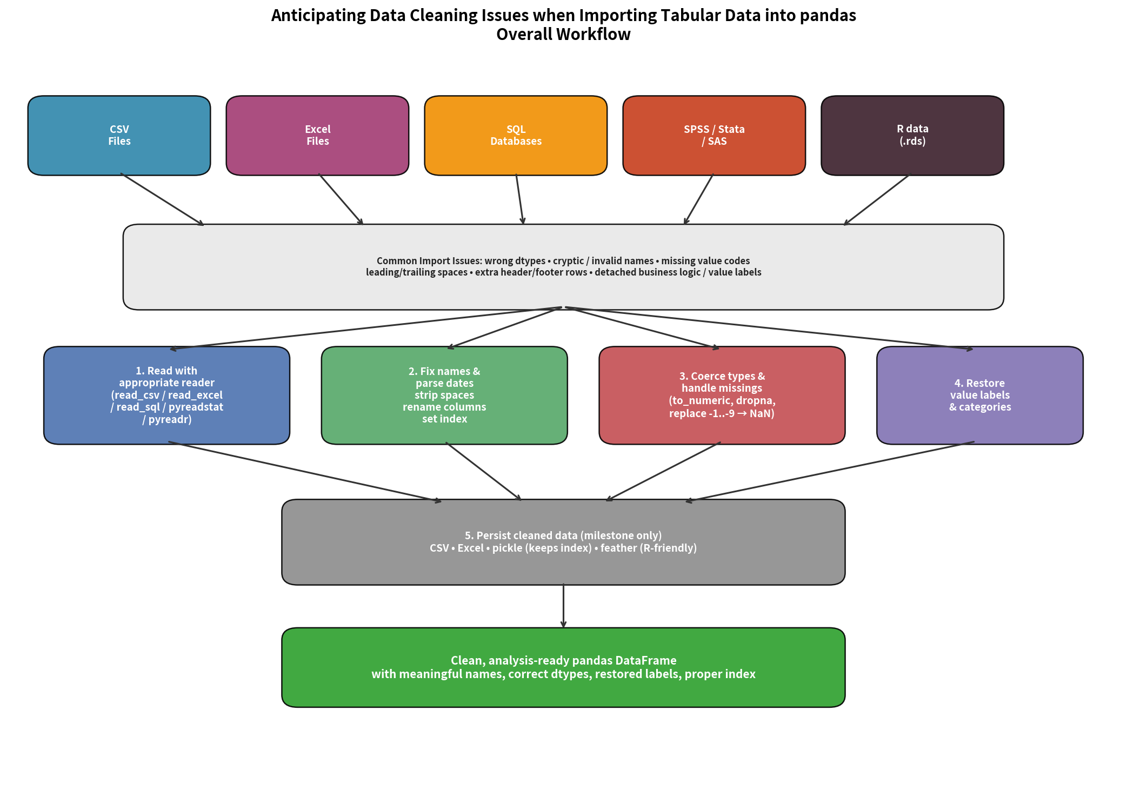

Key Takeaways
1. Never trust the first dtype guess—explicitly parse dates and coerce numerics with errors='coerce'.
2. Restore business meaning (value labels) as early as possible; store as category to save memory.
3. Treat negative codes and sentinel zeros as missing; replace them before any modelling.
4. Persist only at milestones; choose pickle (full fidelity) or feather (R-friendly) according to the next consumer.
5. A short simulation (editable N_ROWS / MISSING_RATE / EXTREME_Q) quickly reveals sensitivity of the pipeline.

